



1. Contents

2. Assignment 2

2.1. Case 2

2.2. Assignment Goals 2

2.2.1. Visualization Deliverables 3

2.2.2. OTHER DELIVERABLES 3

3. Documentation 4

3.1. Vision Diagram 4

3.2. Data Profiling 4

3.3. Data Wrangling and Cleansing 5

3.4. Graph Data Modeling 6

3.5. Database Installation 6

3.6. Data Mapping and Integration 7

3.7. Data Validation and Data Visualization 8

3.8. System Integration and User Acceptance Testing 9

3.9. Challenges Encountered 10

3.10. End User Instructions 11

# Assignment

## Case

Our Dataset case is Dallas Police Incidents.

This dataset is published by the City of Dallas for research purposes only, and it represents the Dallas Police Public Data - RMS Incidents beginning June 1, 2014 to current-date. The Dallas Police Department strives to collect and disseminate police report information in a timely, accurate manner. This information reflects crimes as reported to the Dallas Police Department as of the current date. Crime classifications are based upon preliminary information supplied to the Dallas Police Department by the reporting parties and the preliminary classifications may be changed at a later date based upon additional investigation.

This is an attempt to make it easier for citizens to access offense reports. In disseminating this crime information, we must also comply with current laws that regulate the release of potentially sensitive and confidential information. To ensure that privacy concerns are protected and legal standards are met, report data is "filtered" prior to being made available to the public. Among the exclusions are:

a.) Sexually oriented offenses

b.) Offenses where juveniles or children (individuals under 17 years of age) are the victim or suspect

c.) Listing of property items that are considered evidence

d.) Social Service Referral offenses

e.) Identifying vehicle information in certain offenses

## Assignment Goals

To work with datasets, Perform/Create:

* Group assignment project in Velero: Group 8 - Dallas Police Incidents
  + Project (Short Form)

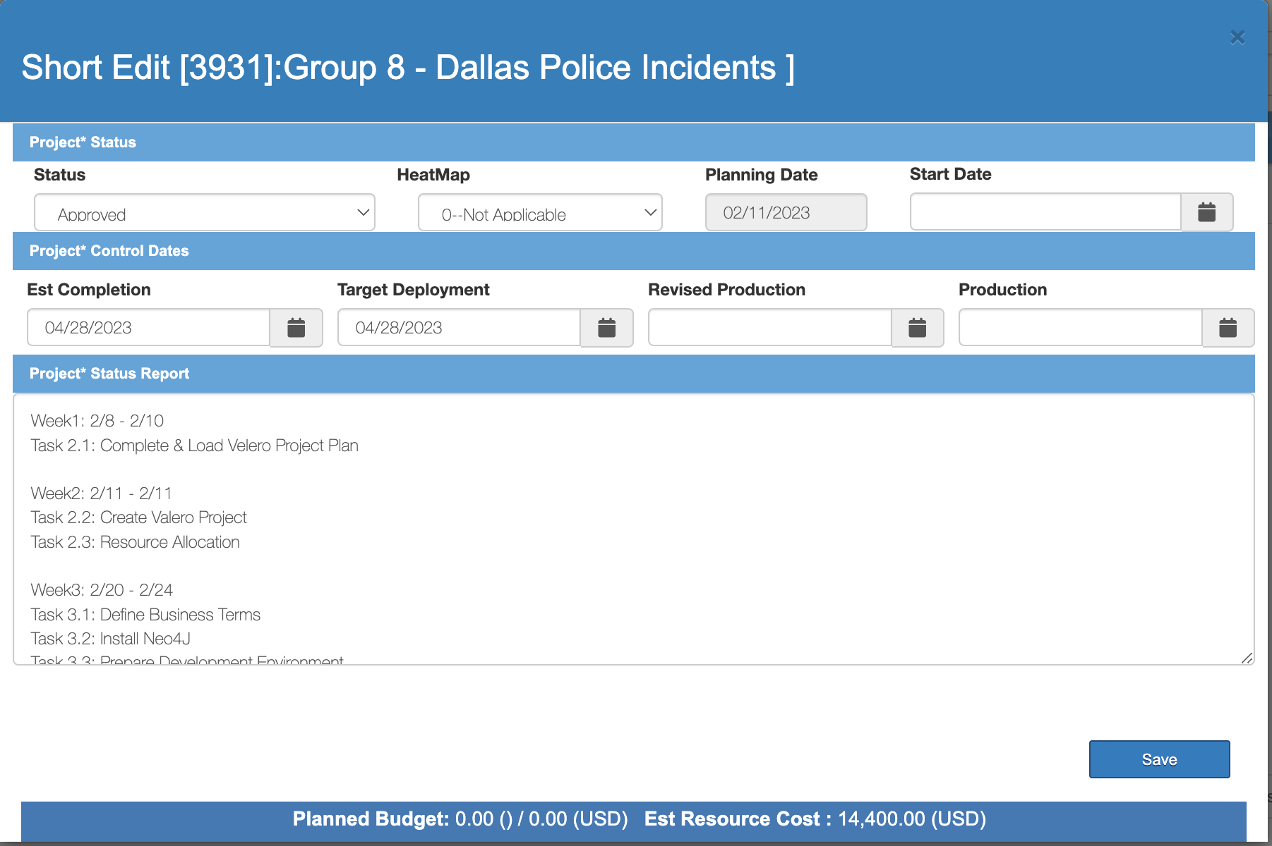

* + Project (Long Form)

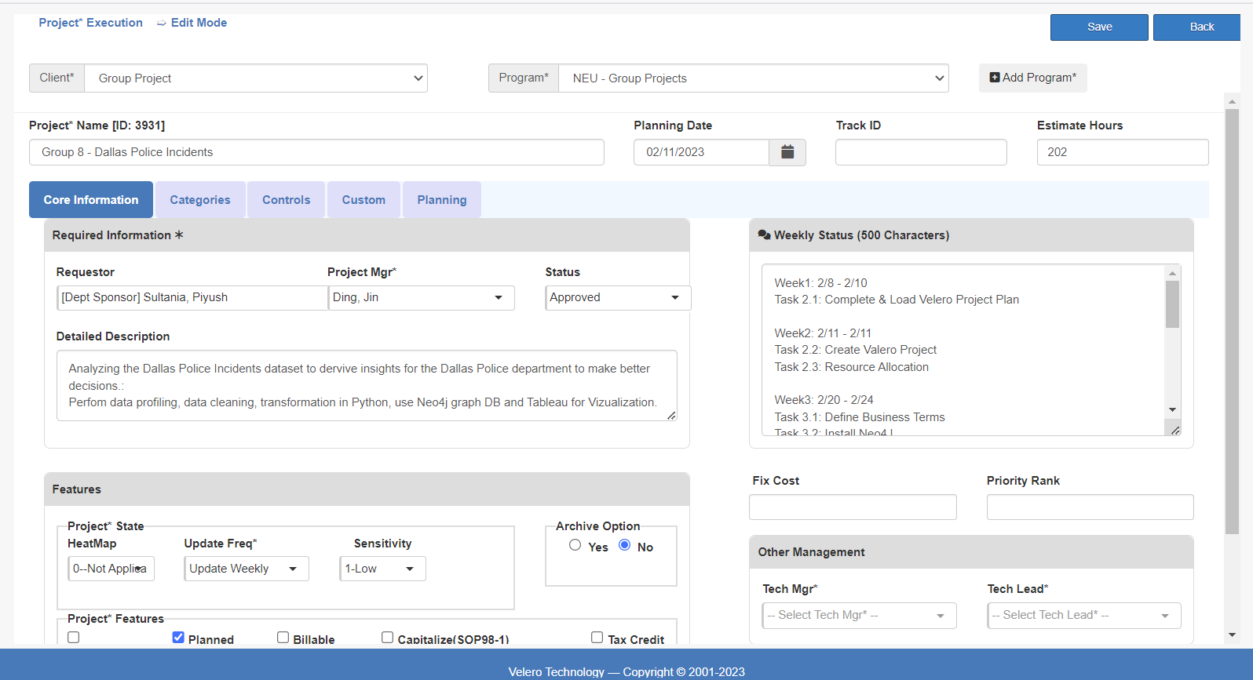

* + Project Plan (Tasks)

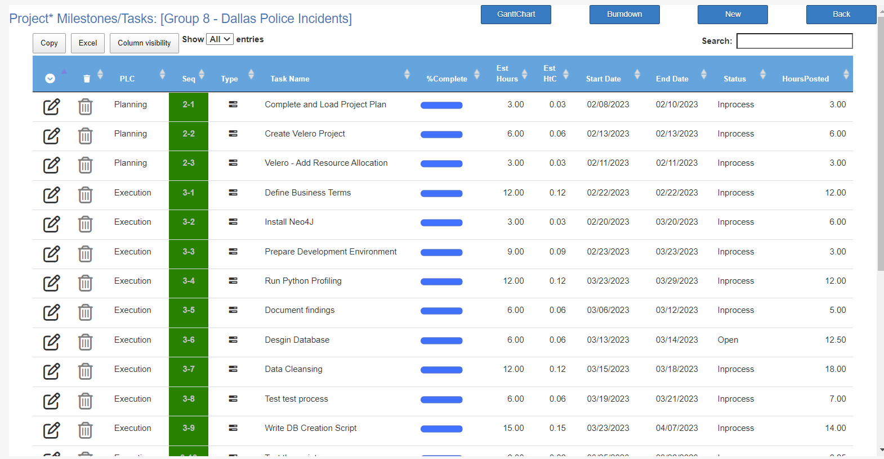

* + Resource Allocation

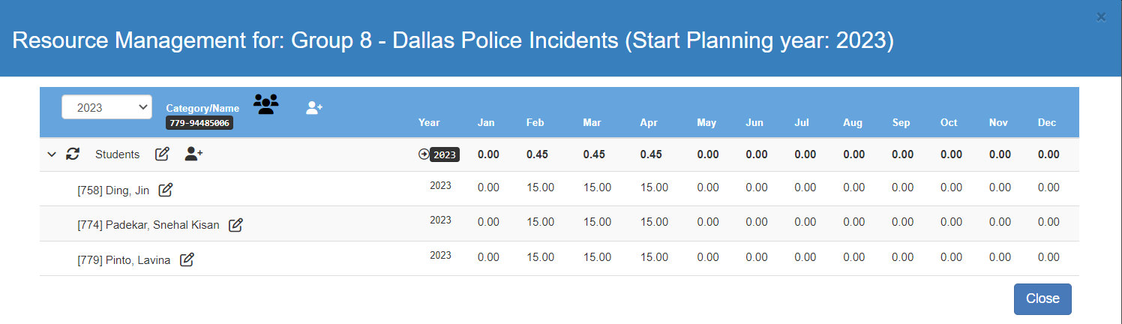

* + Timesheet

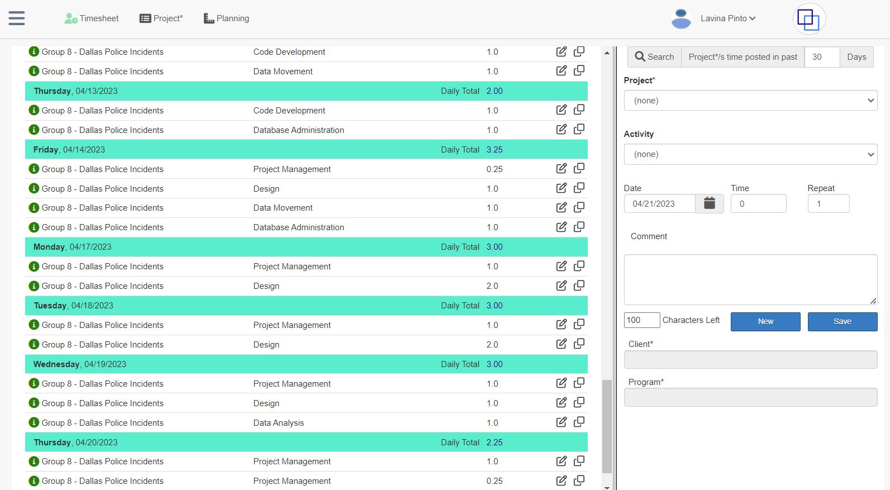

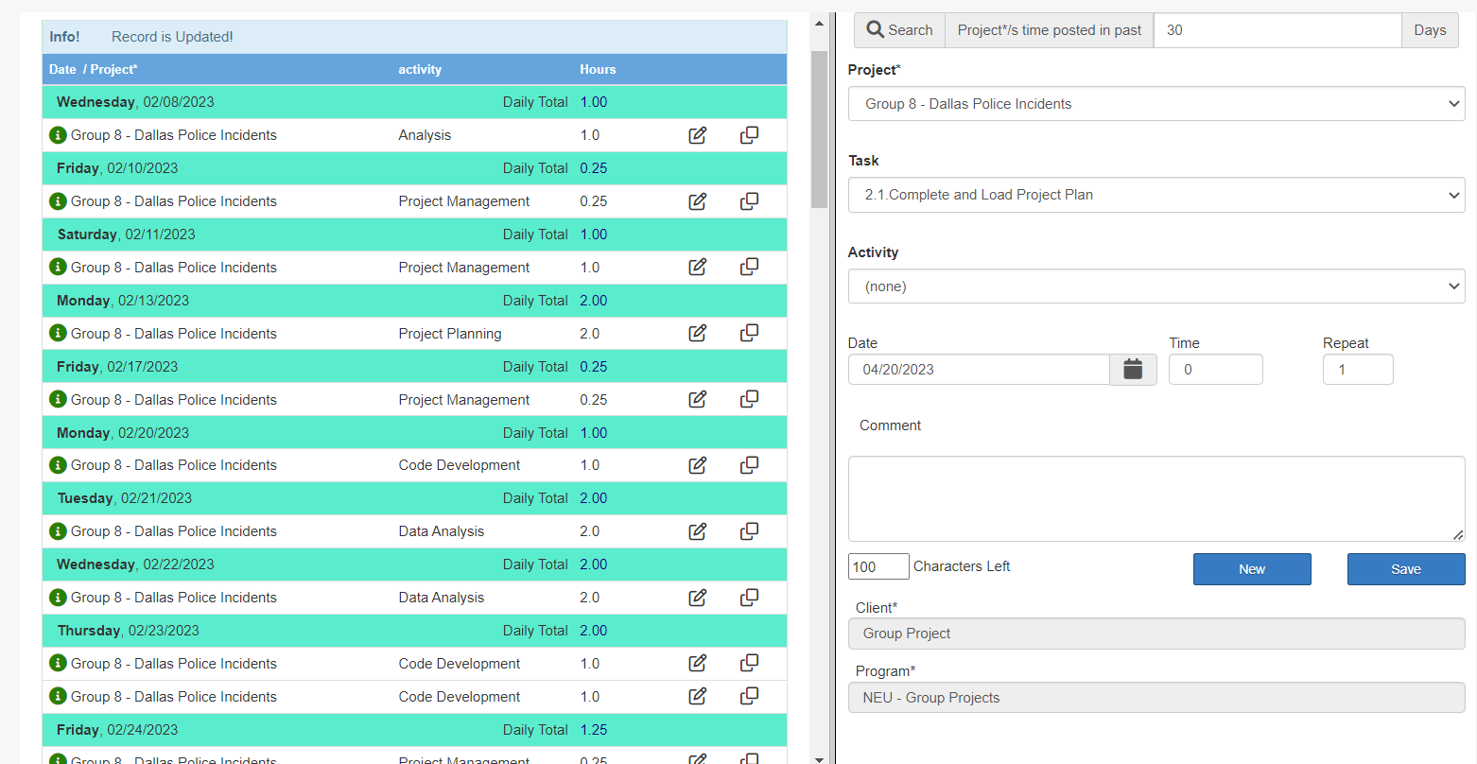

* + Issues & Risks

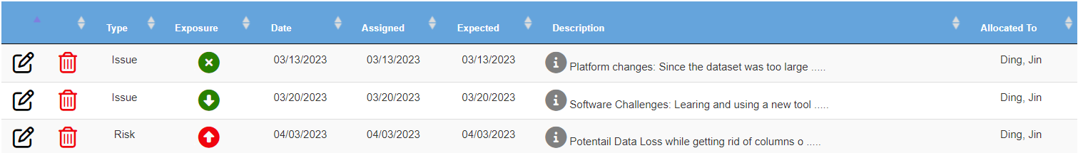

* **Data Profiling** – Using the Python profiling library, describe your understanding of the data.

* **Data Wrangling and Cleansing** – Use a Python program to:
  + Filtering and aggregating if needed.
  + Missing value handling.
  + Deriving additional columns from existing datasets if needed.
  + Cleaning (removing blank spaces, formatting dates, Capitalizing, etc.).
* **Database Installation:** Install the NEO4J database.
* **Business and Technical Metadata** – develop a business term list describing all the data elements available in the file.
  + Business Terms in Velero Metadata

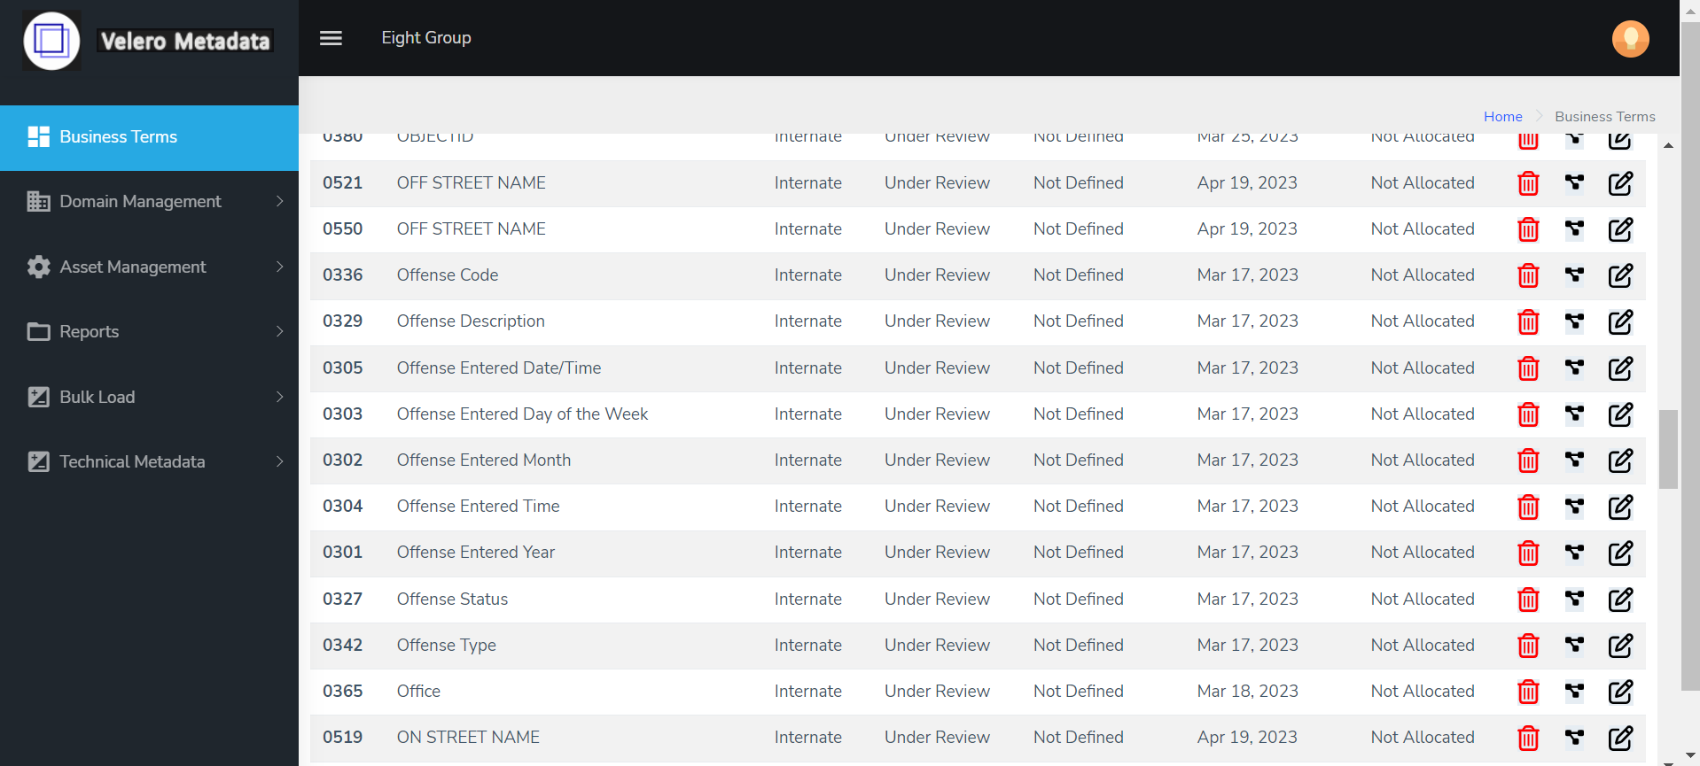

* **Data Validation** – Validate the data using python data libraries.
* **Data Visualization** – Create a presentation dashboard to reflect your understanding of the data, you may use python visualization libraries, Power BI, or Tableau
* **System Integration and User Acceptance Testing** - Test Cases – describe your validation & testing process.
* **Risks/Issues** – identify risks and issues related to your project and describe how you resolved them.
  + Issues

Platform changes: Since the dataset was too large our dataset was not getting uploaded to Google Colab and we had to switch to Jupyter Lab for data profiling and data cleaning

Software Challenges: Learning and using a new tool (Neo4j) was time consuming

- Learning CQL

- Insufficient online resources

- Change in memory settings for faster loading of data

* + Risk

No prior experience with Neo4j graph database

Potential Data Loss while getting rid of columns or rows with null, ambiguous and uncleaned entries

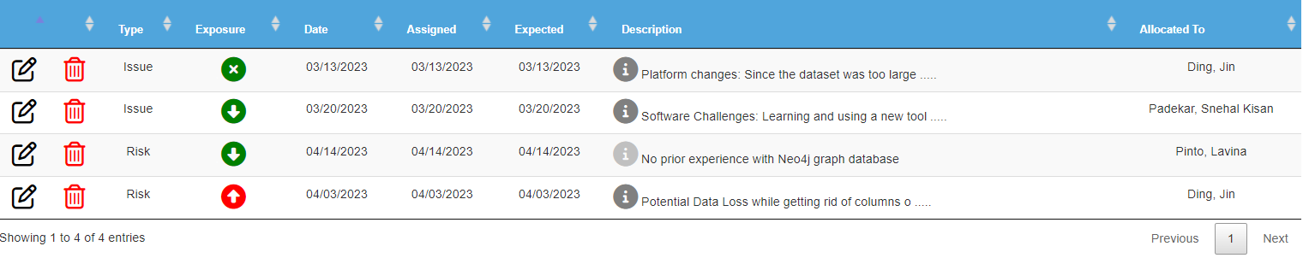

* **End User Instructions (Steps to run your Dashboard)** – provide a full description of how to run your process:
  + Database Creation and load.
  + Visualization interpretation - describe information regarding your findings.

### Visualization Deliverables

Once you wrangle/clean/join/integrate the data, import the data into **NEO4J** and illustrate how to use the appropriate graph to illustrate various aspects of analysis. Provide a complete explanation of the dashboard and usability.

Questions to answer:

* Who is using this dashboard and how do they benefit from your dashboard?

Dallas Police Department

US Criminal Department

Citizens of Dallas and US

* What value would be generated using this dashboard?

Incidents in Divisions

Incidents based on Victim Race (Top 6)

Incidents based on Victim Type (Top 6)

Incidents based on Gender

Incidents Occurred Year Wise

Incidents Occurred During Watch  
Incidents in ZipCode  
Gang Related Incidents

* What data are used for dimensions and columns are used for measurement?

Incident node, incident number, victim gender, etc.

### OTHER DELIVERABLES

* Presentation of the entire work from the first step to the dashboards including the Velero screenshots.
* Business and technical metadata presentation – Identifying all available business terms and extracting related technical metadata.
* Complete instructions on how to implement and run the database load, technical metadata extraction, and dashboard.

Below are different types of deliverables that are prepared for our project:

Business Terms and Project Plan

Jupyter Notebook

Cypher scripts

Tableau

Velero screenshots

# Documentation

## Vision Diagram

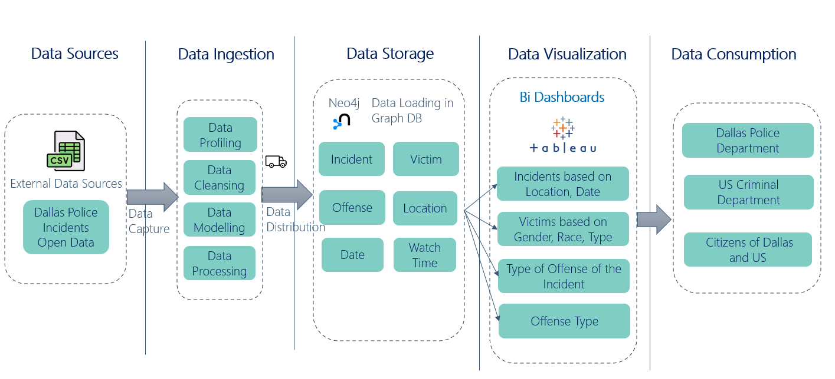

## Data Profiling

We Performed data profiling on the dataset using pydata-profiling library in python.

We studied the dataset columns and checked the type of data, missing values for each column.

We found 2 columns which has almost all values as NULL, hence we decided to drop those 2 columns.

**Observations:**

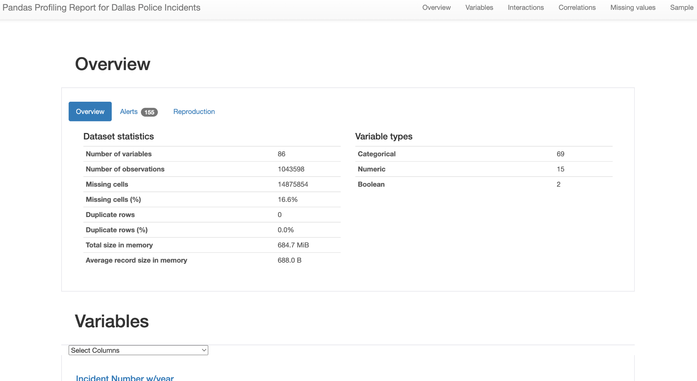

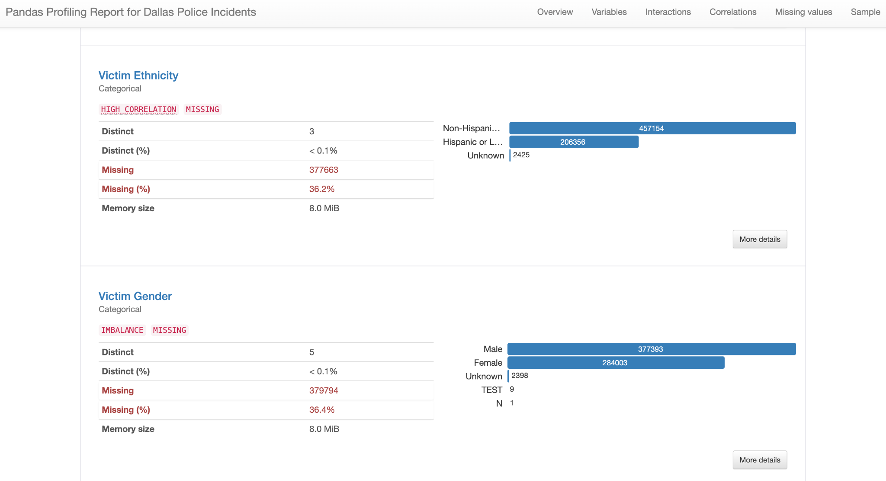

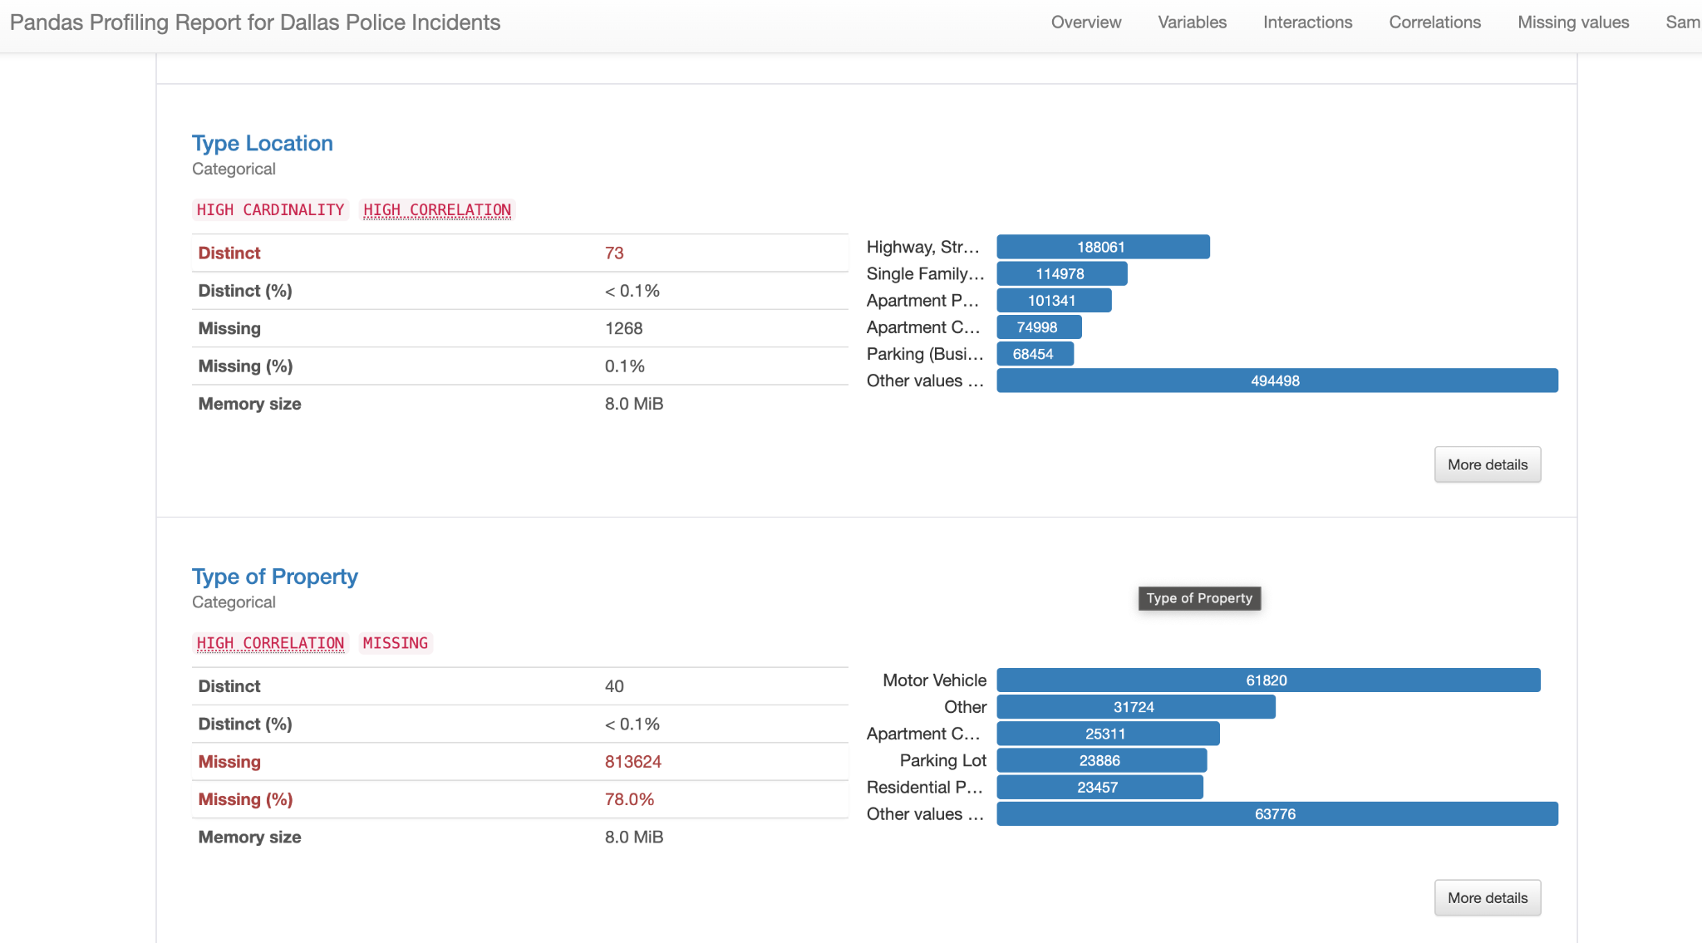

## Data Wrangling and Cleansing

Data Cleansing

1. Renamed columns according to the business terms. We defined business terms for the columns and renamed the columns to an appropriate column name in python.

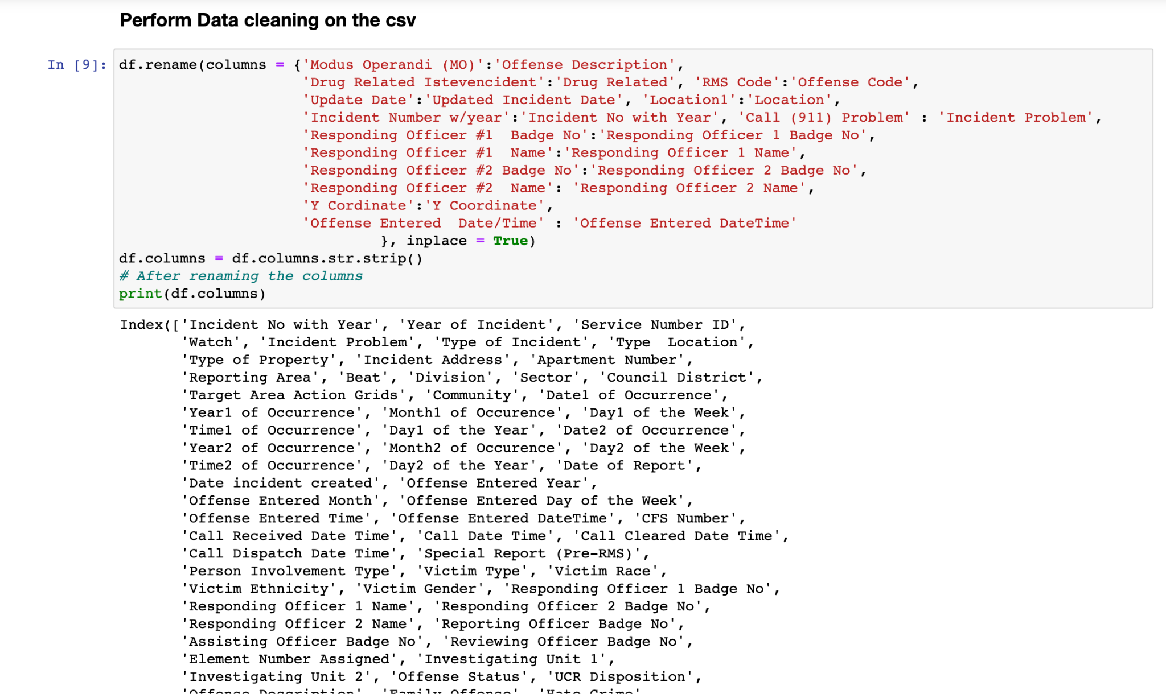

1. Checked null values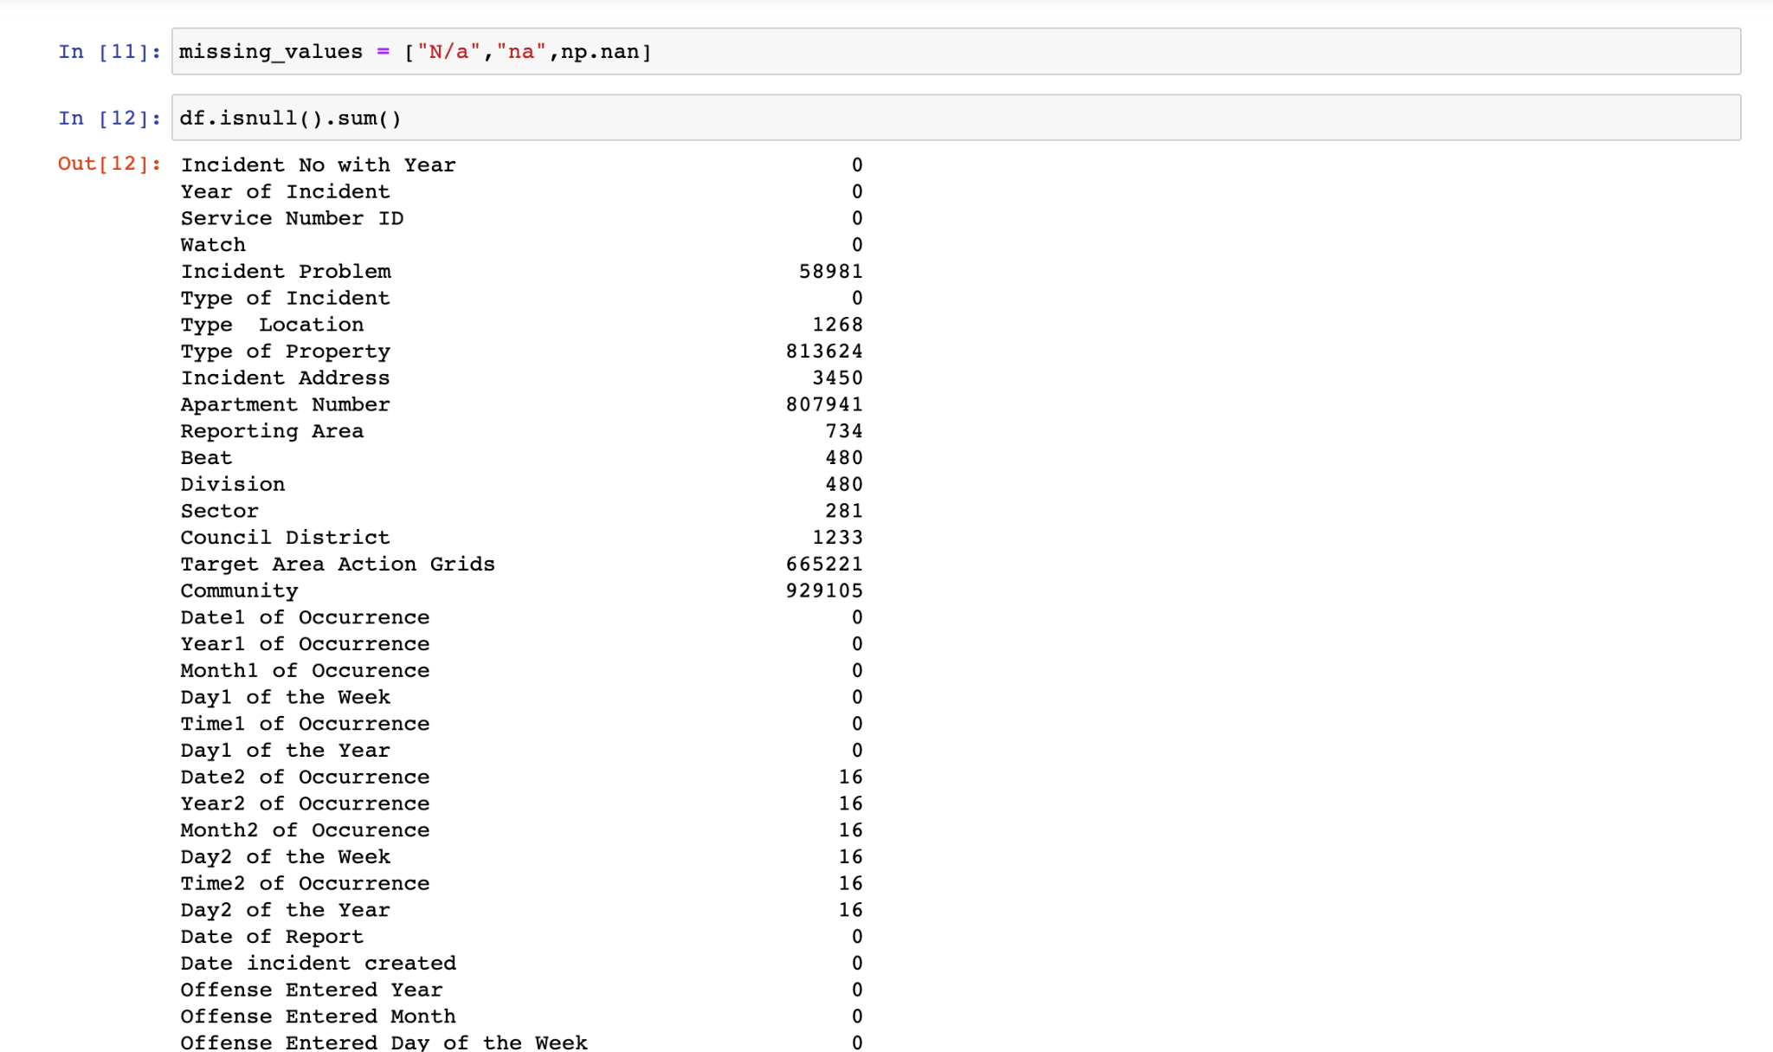
2. Dropped duplicates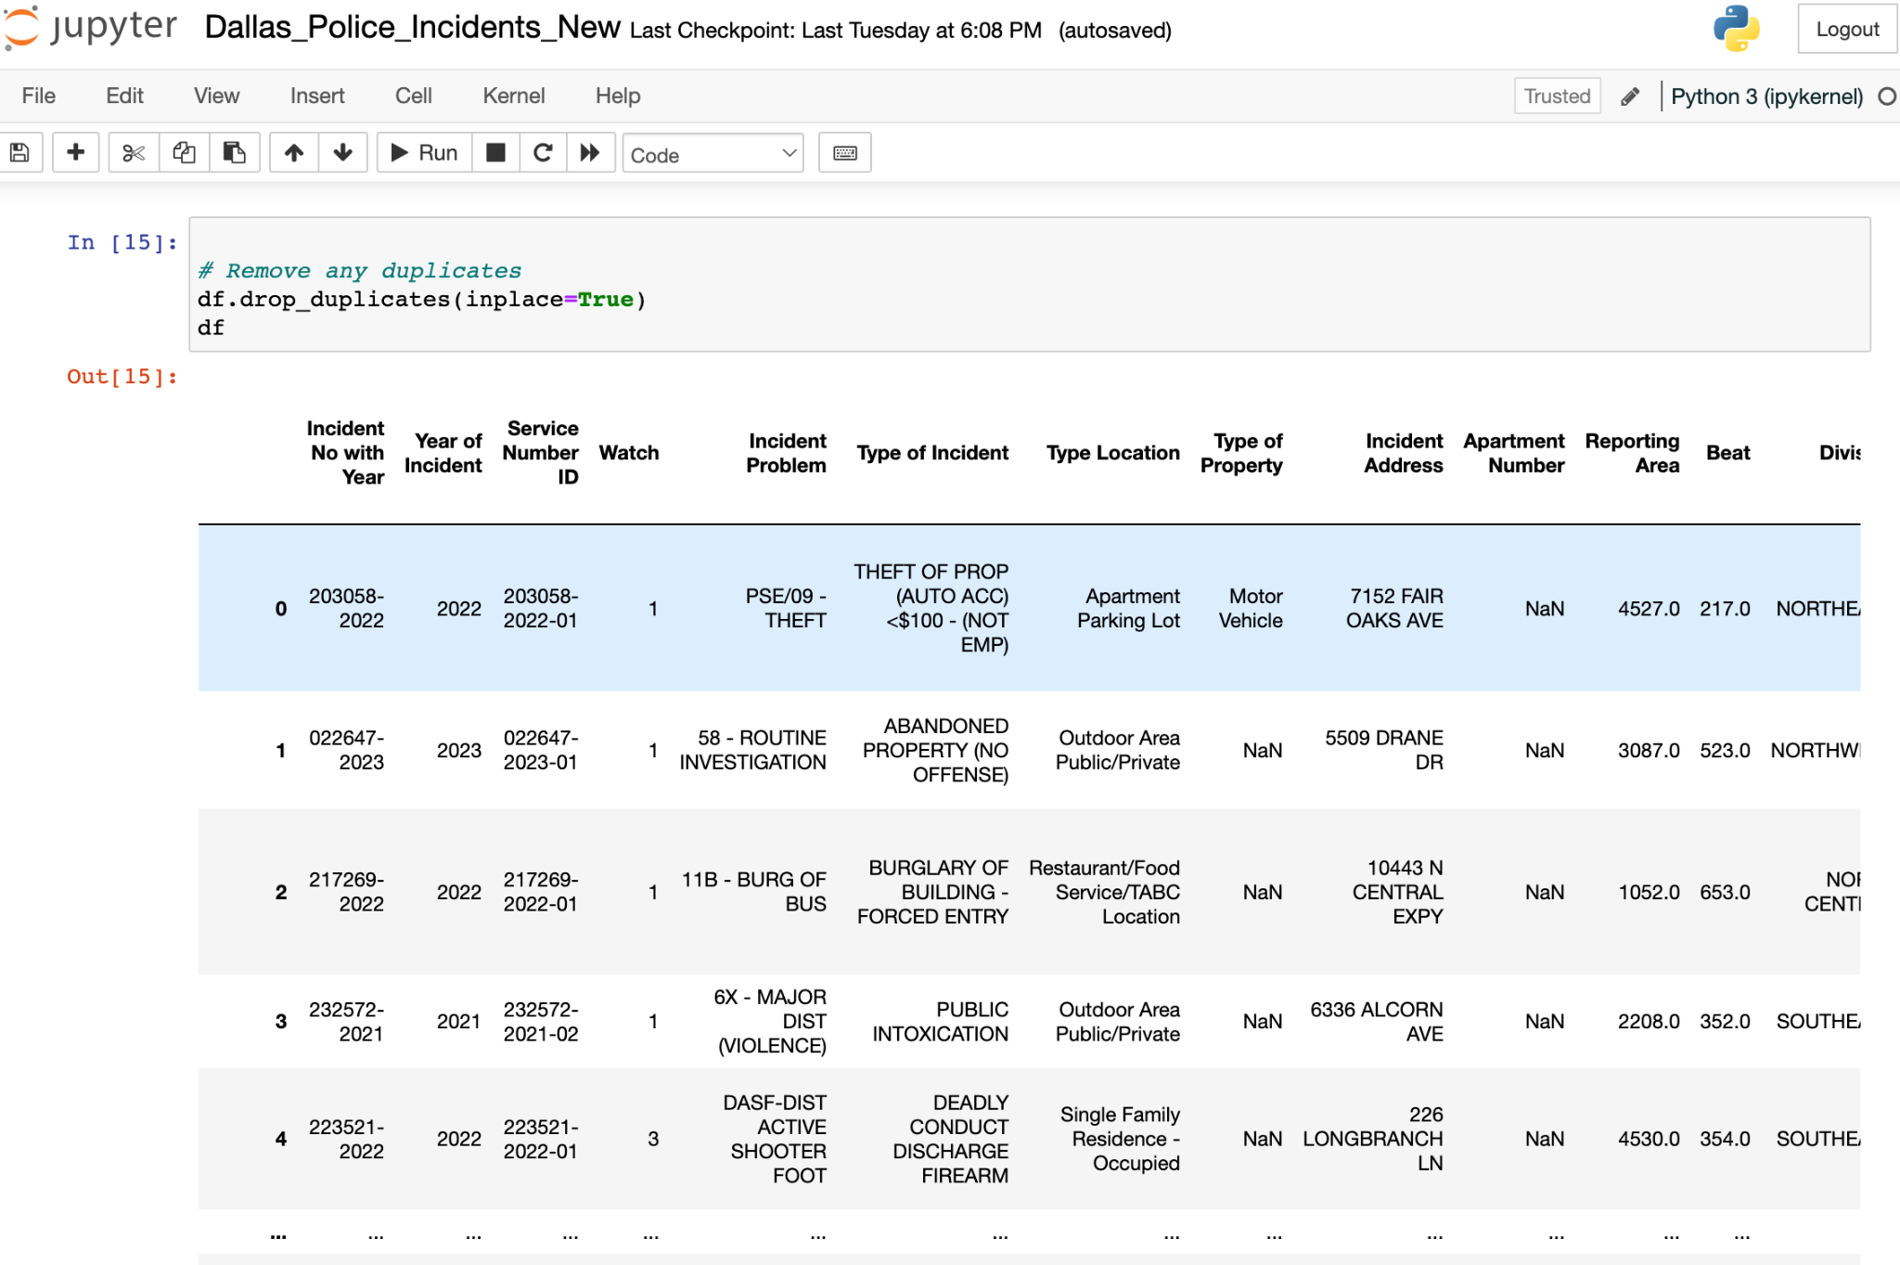
3. Renamed the column state to its full name and renamed the day of the week to its full name 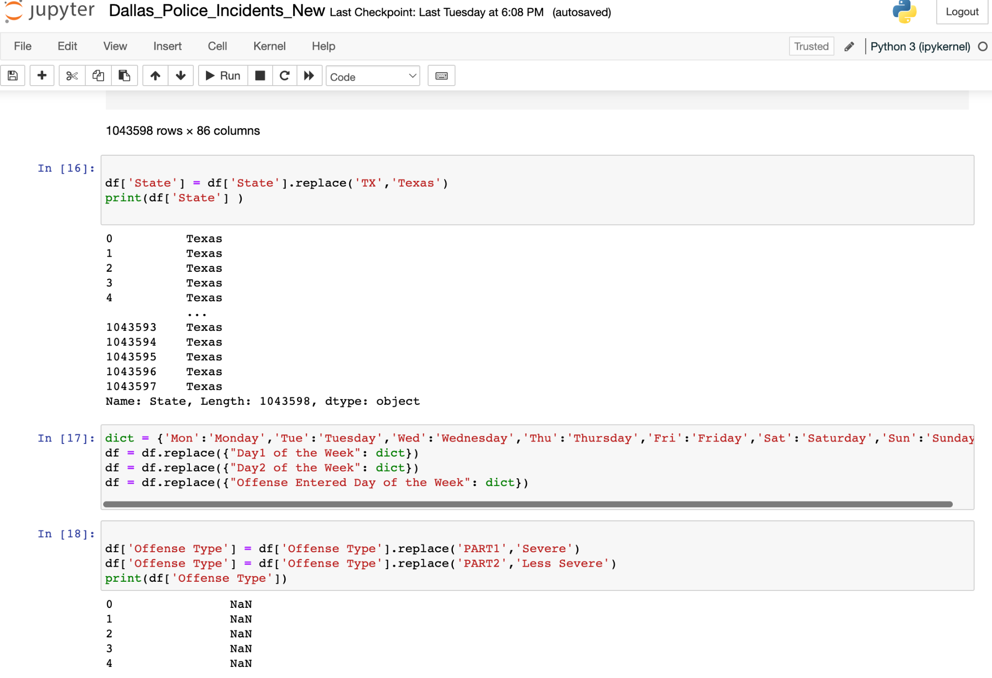
4. Dropped 2 columns which had 99.6% records as NULL.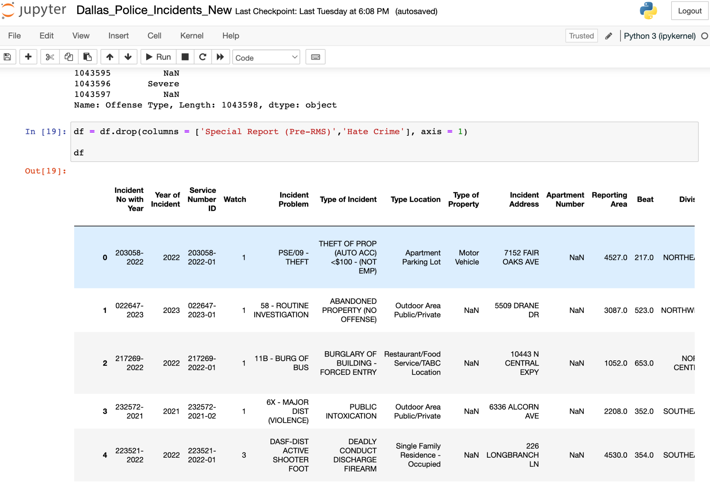
5. Filled the numeric data type null columns with an integer value  
   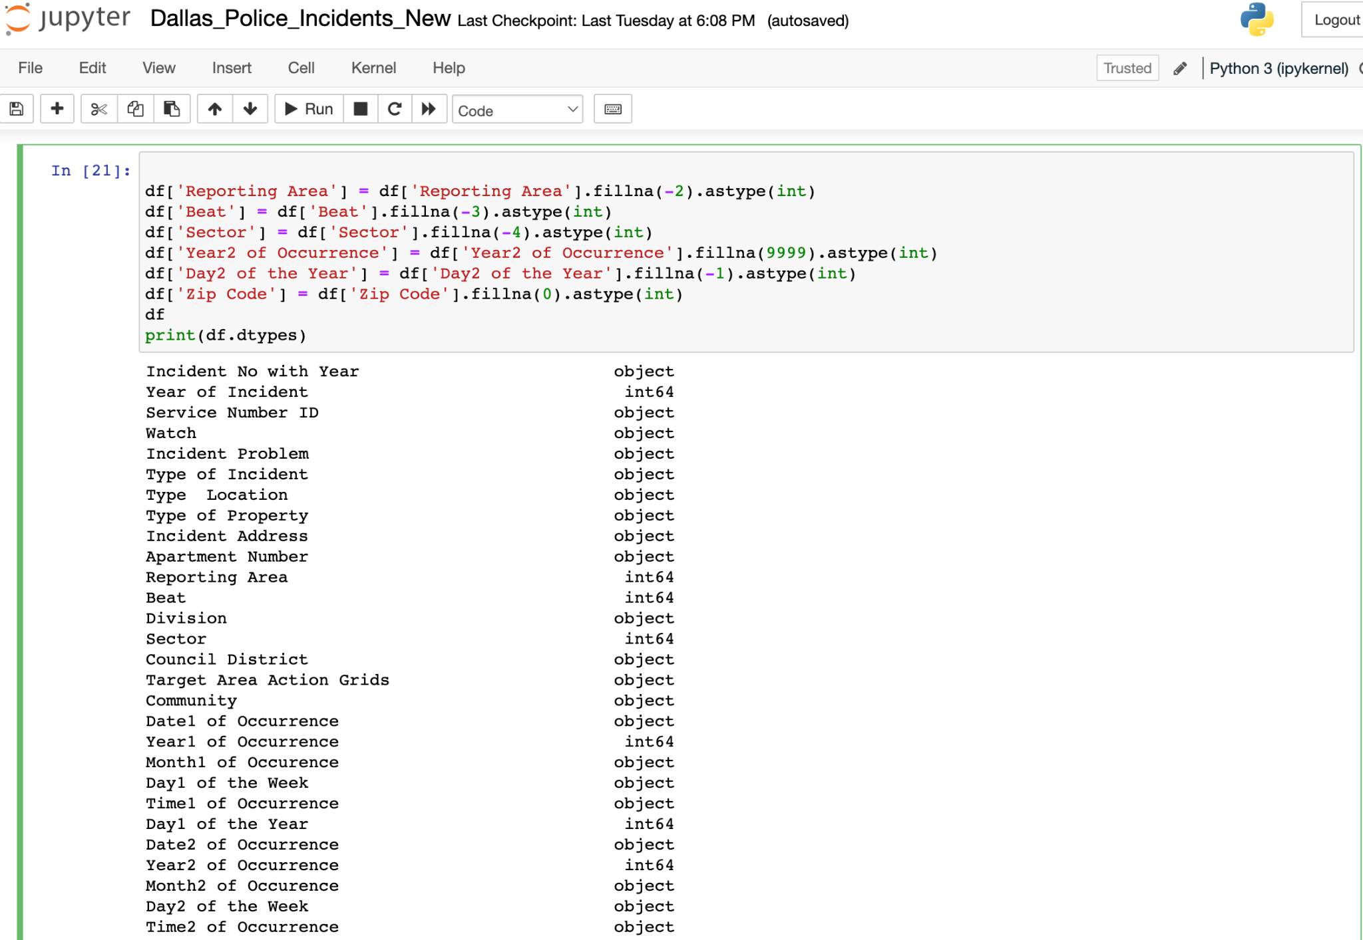
6. Filled the string data type null columns with ‘Unknown’

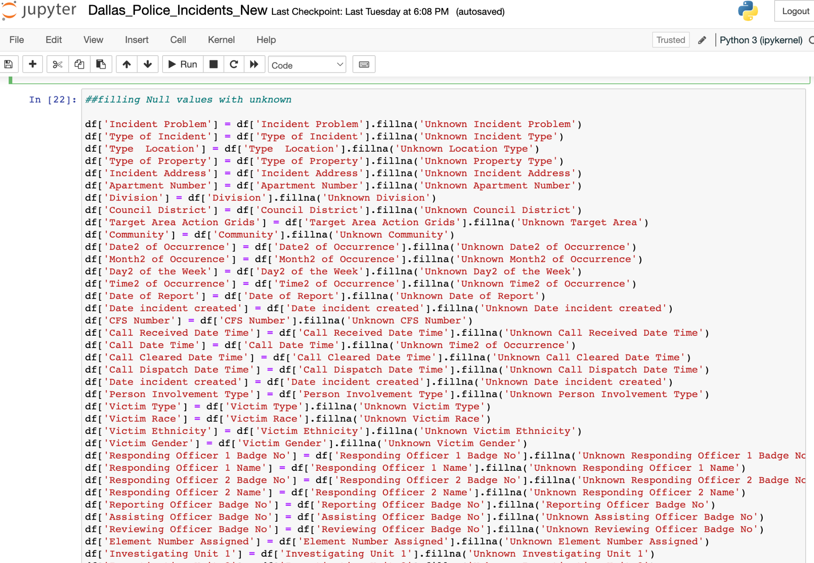

1. The column City had many uncleaned data for the city name like DAAL, DALALS, DALAS

So we renamed them all to Dallas.

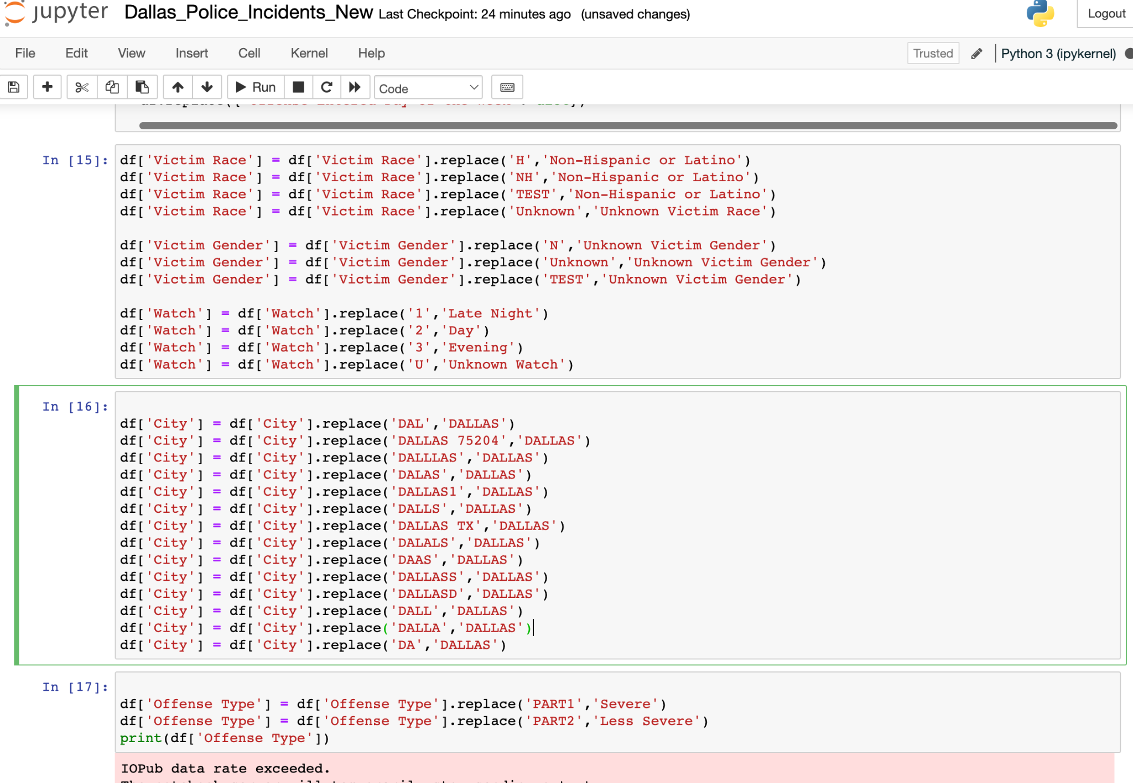

1. We renamed the State as Texas wherever the city is Dallas.

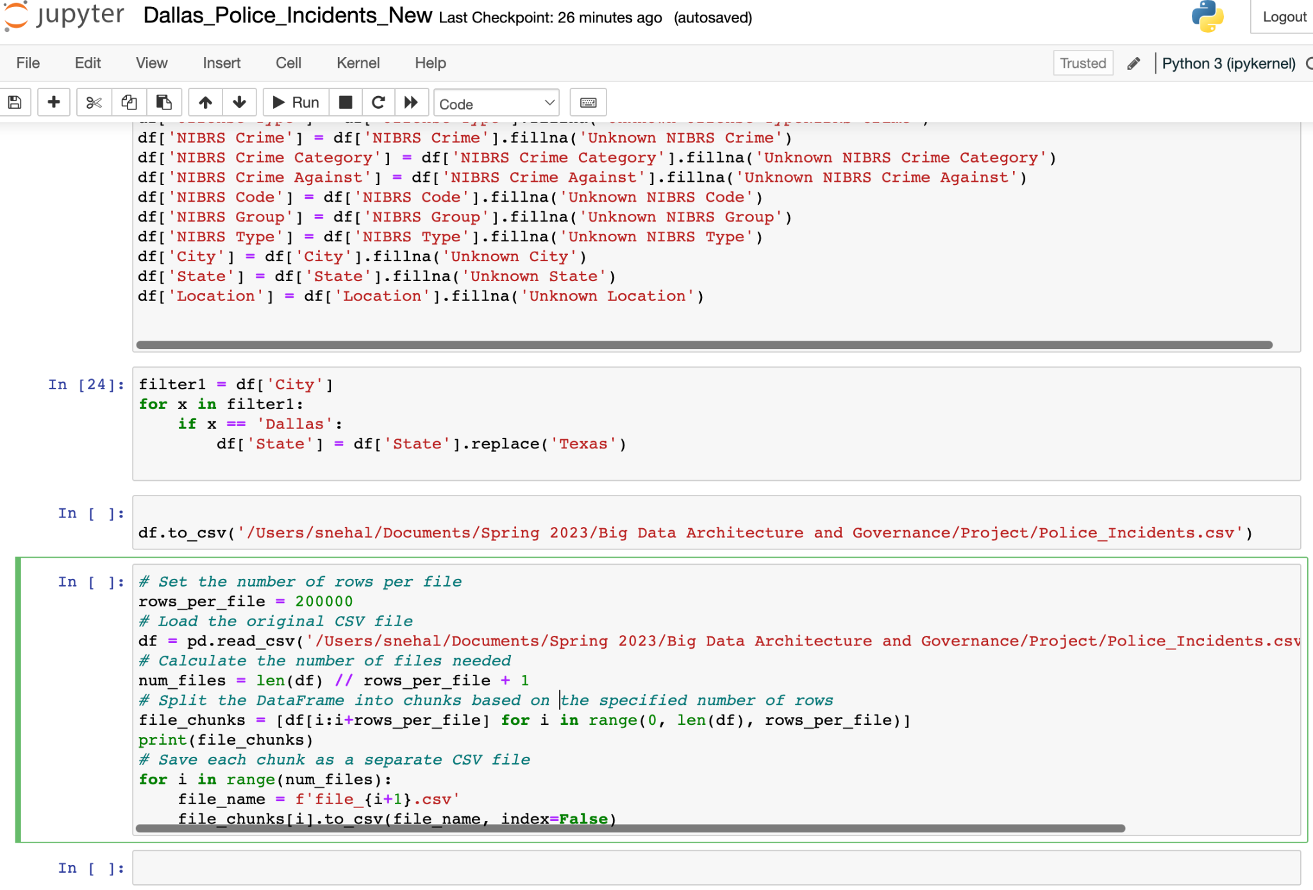

## Graph Data Modeling

Graph Design based on the Dallas Police Incidents dataset

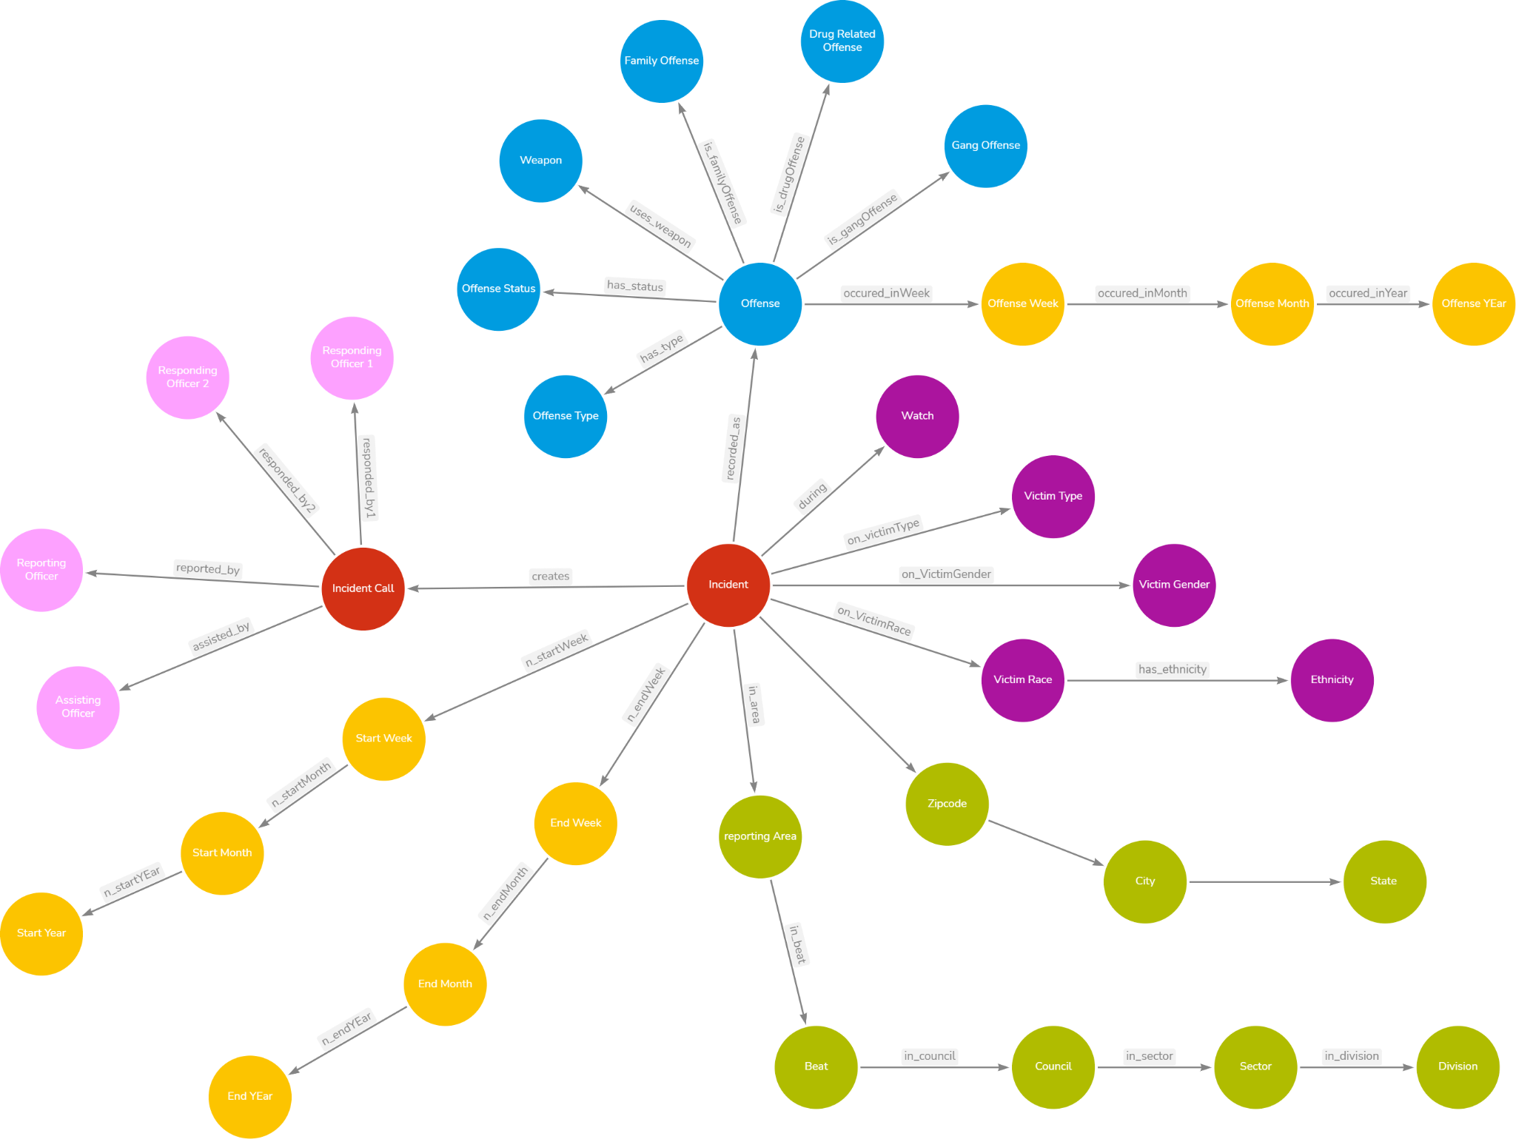

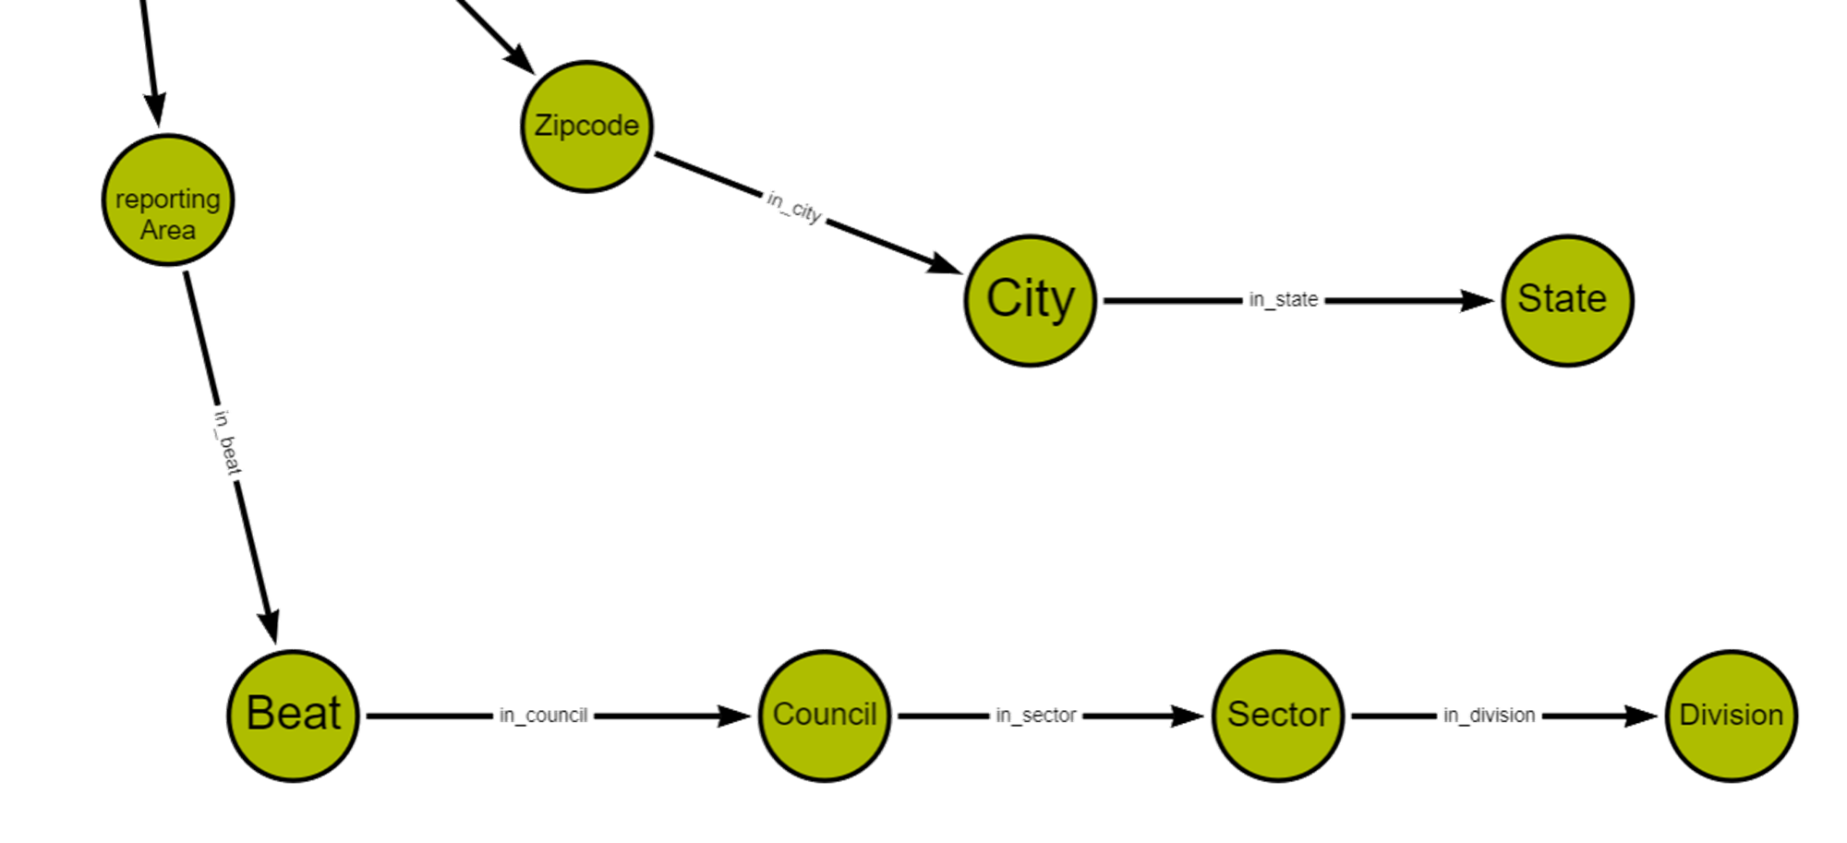

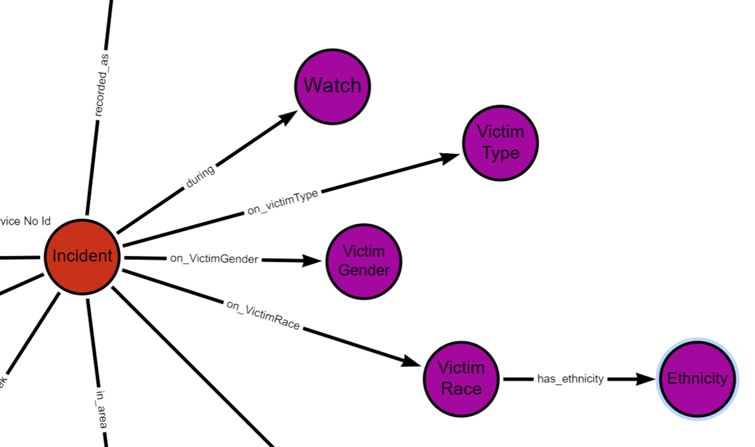

## Database Installation

a). Installed Neo4j Database

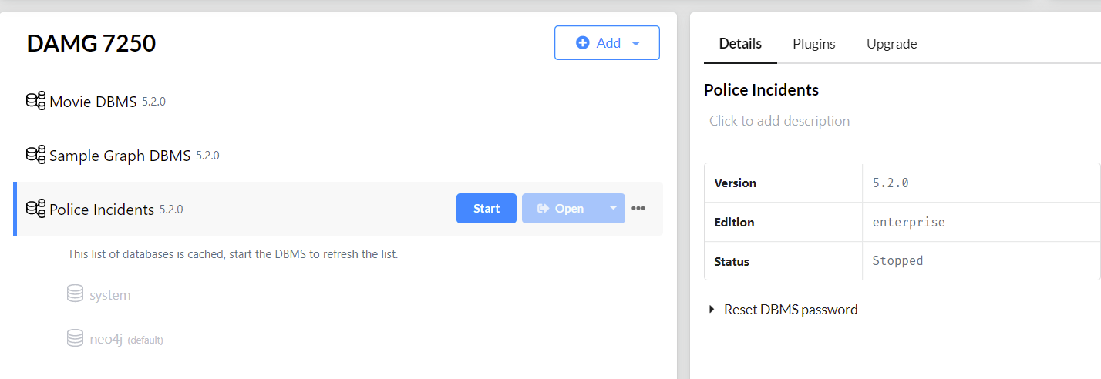

b). Changed memory settings for faster loading and processing of data

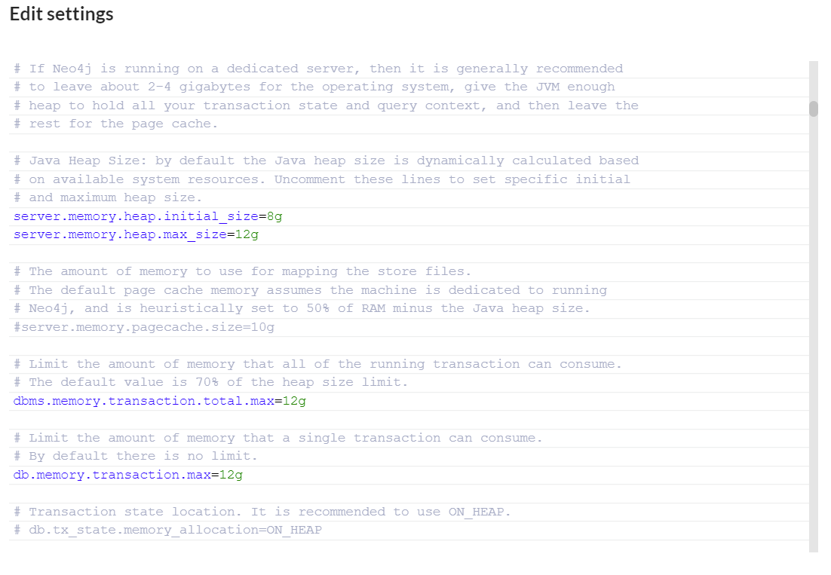

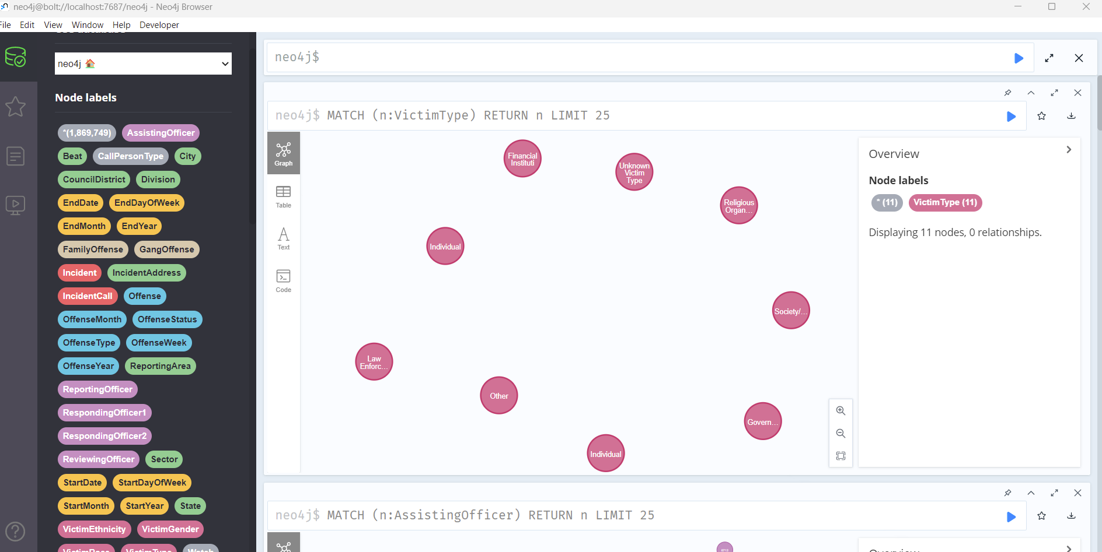

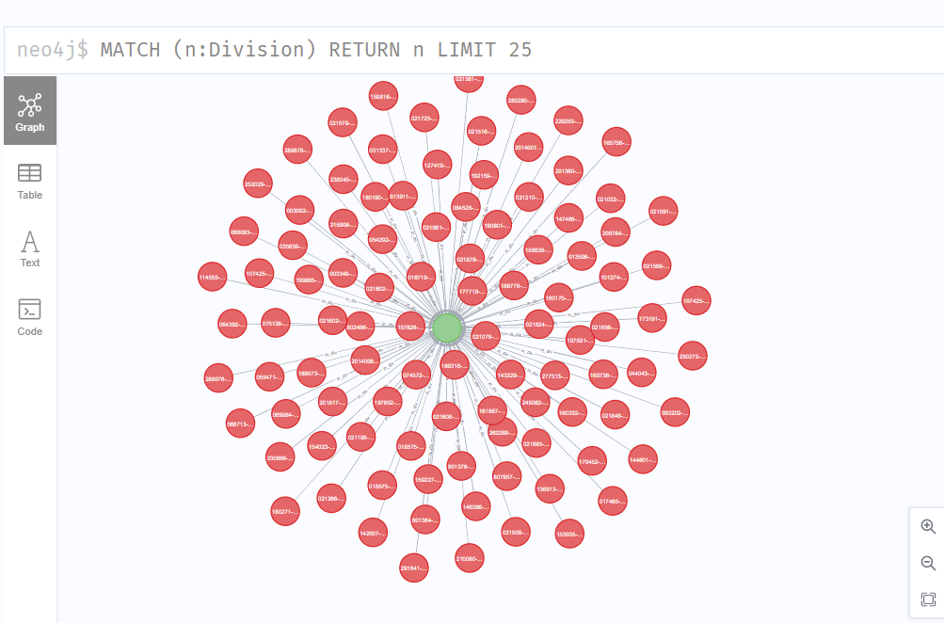

## Data Mapping and Integration

Data Mapping in Tableau

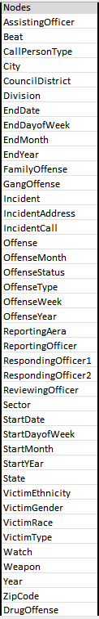

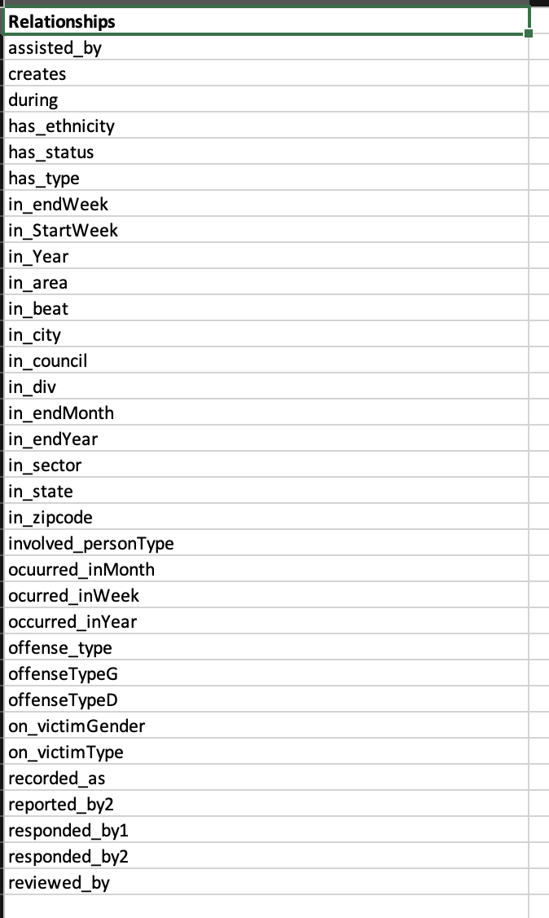

## Data Validation and Data Visualization

### Data Validation

Integration Tableau visualization tool with Neo4j graph DB to visualize the data.

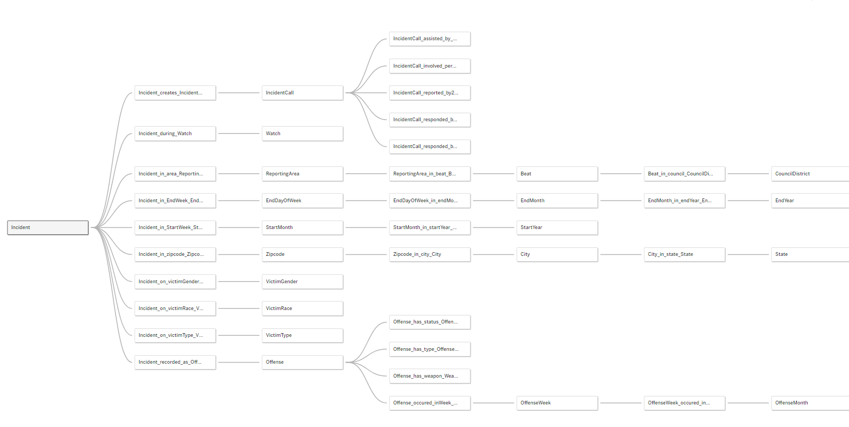

### Data Visualization

a.) Incidents in Divisions

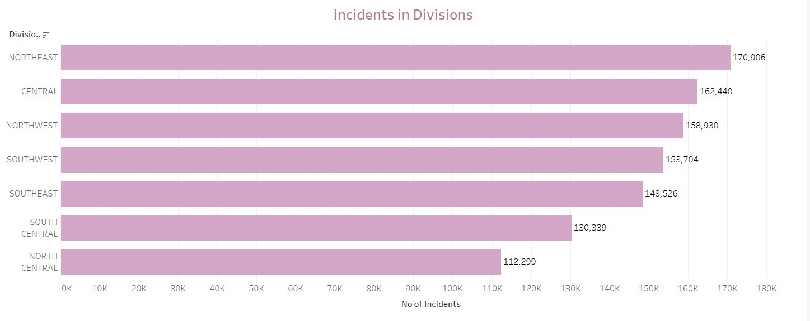

b.) Incidents based on Victim Race (Top 6)

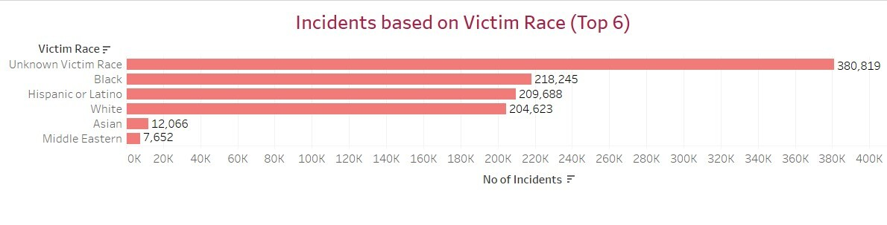

c.) Incidents based on Victim Type (Top 6)

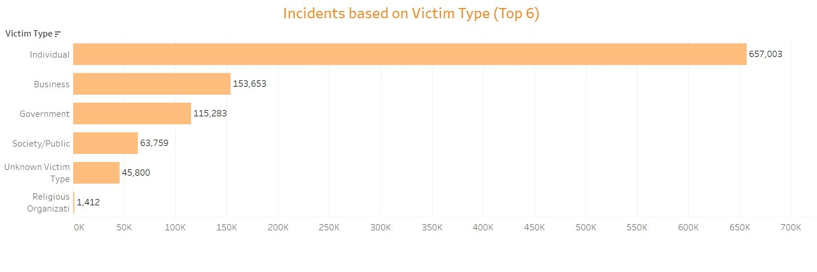

d.) Incidents based on Gender

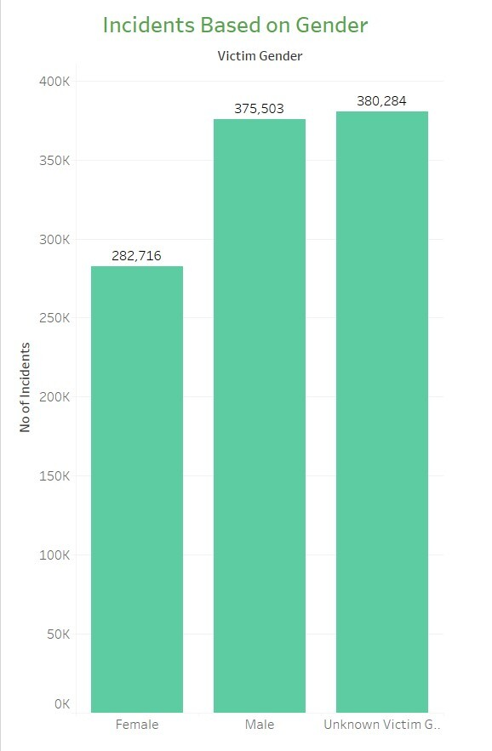

e.) Incidents Occurred Year Wise

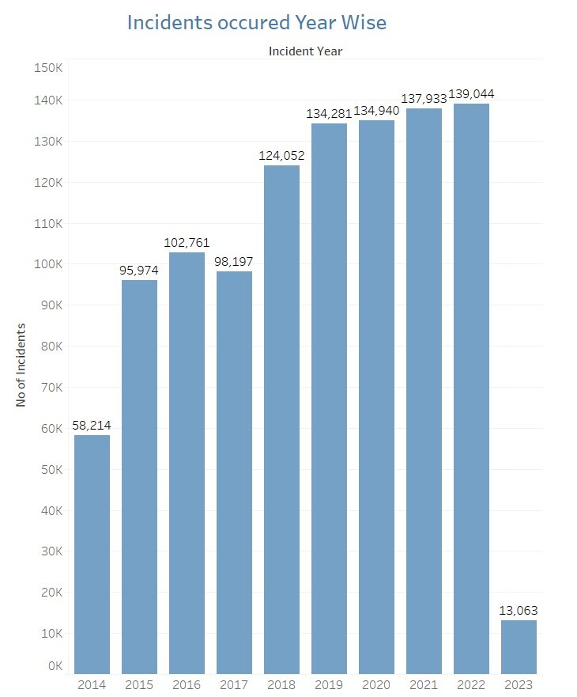

f.) Incidents Occurred During Watch

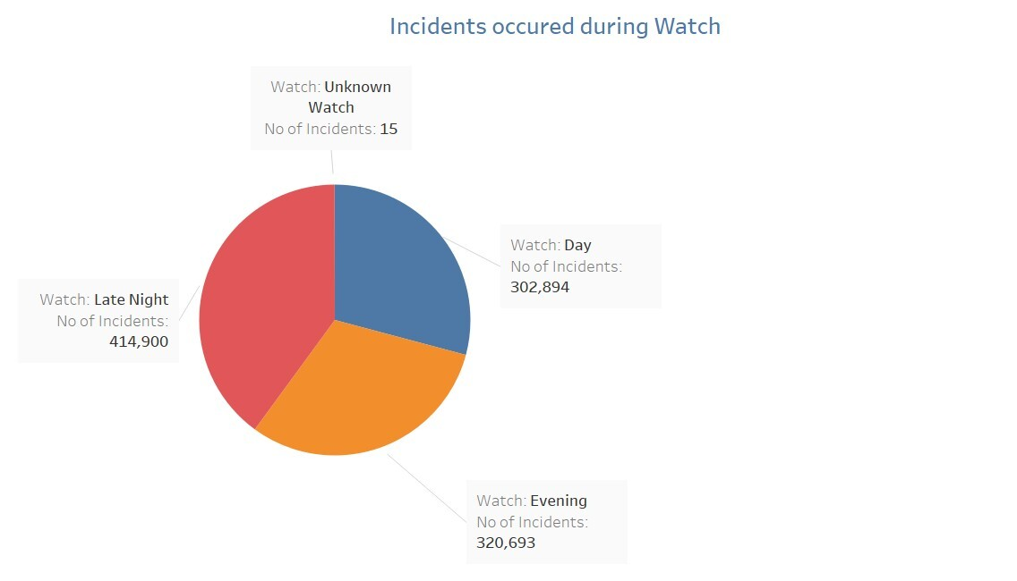

g.) Gang related Incidents

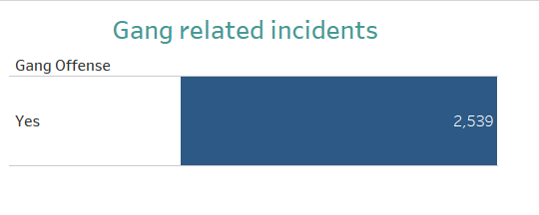

h.) Incidents in Zipcode

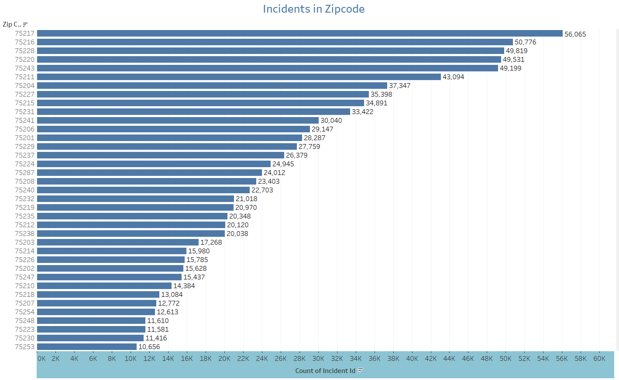

i.) Drug Related Incidents

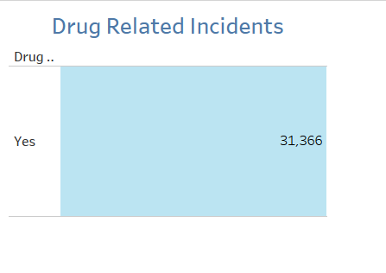

## System Integration and User Acceptance Testing

**Test Case 1 : Checking for NULL values**

Test Description : Null values were assessed and handled accordingly.

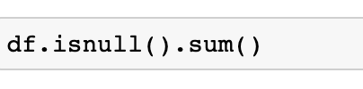

**Before** **After**

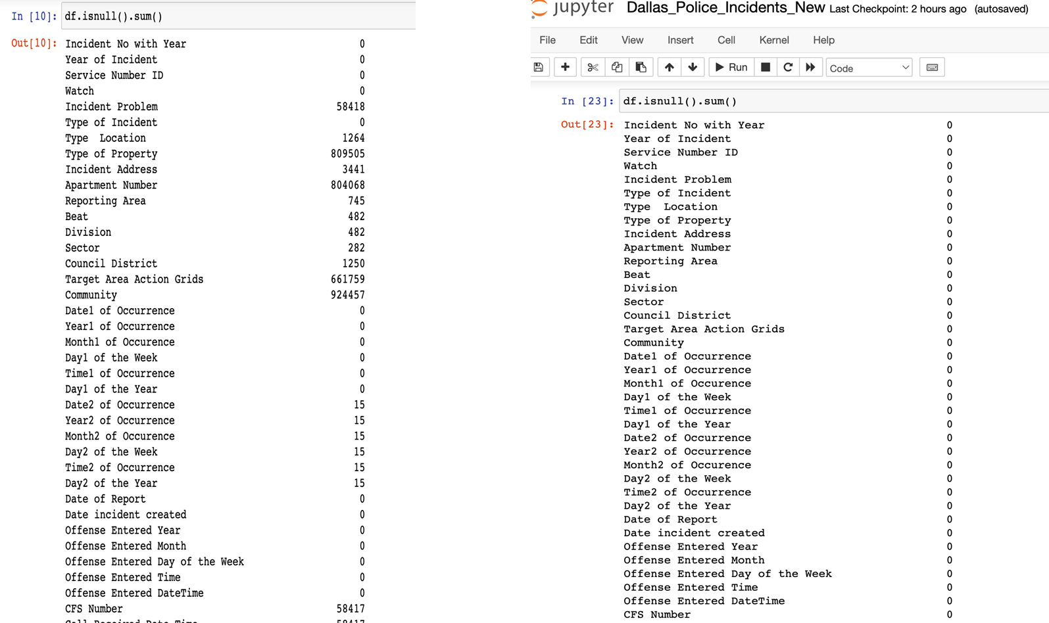

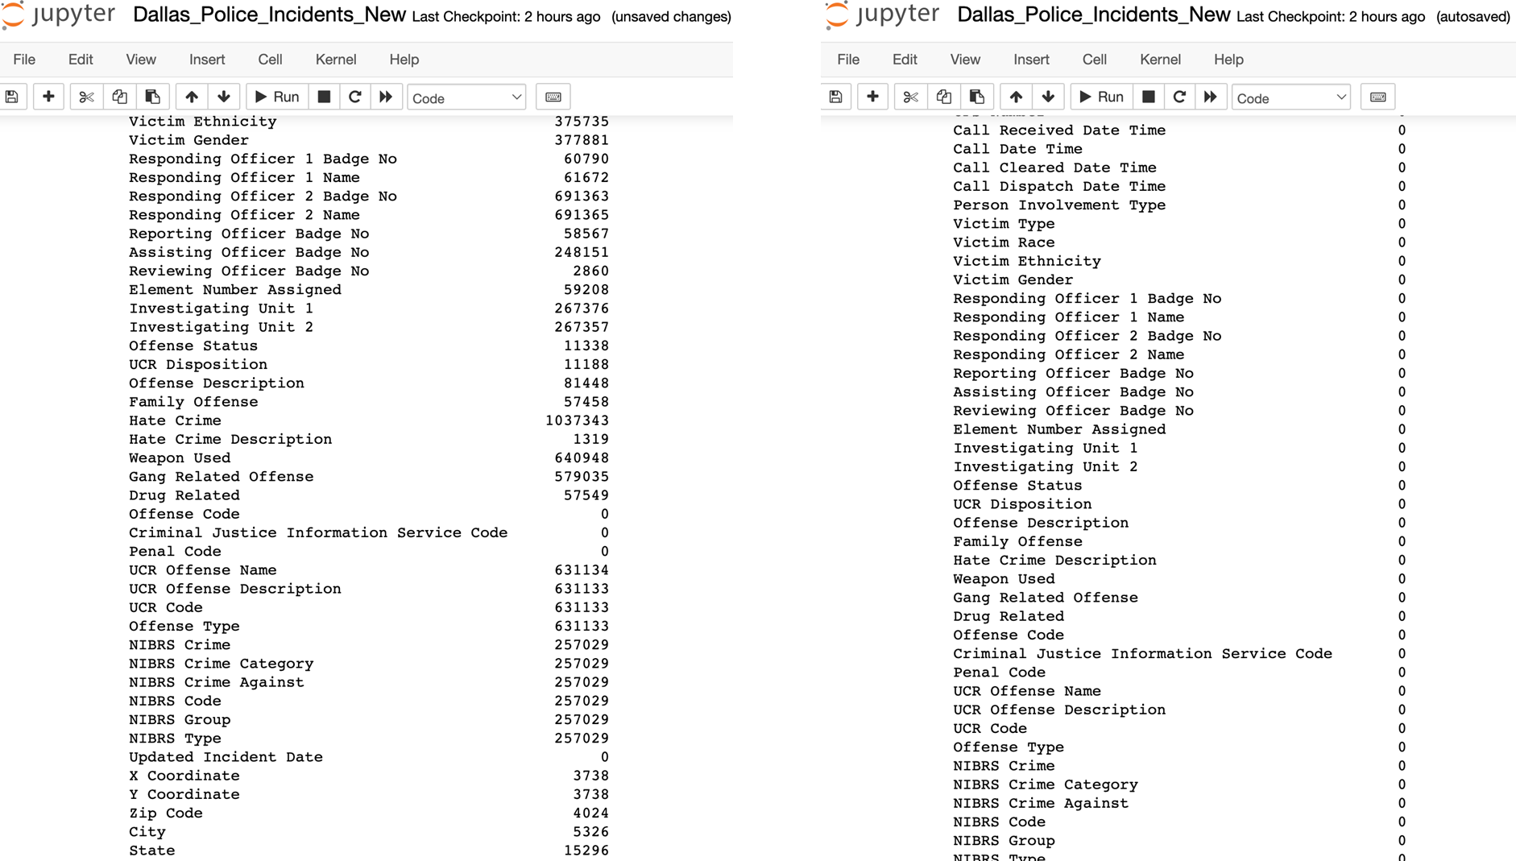

**Test Case 2 : Renaming Columns**

Test Description:

Renamed specific columns for better understanding pertaining to business terms. Ensured that the columns very successfully renamed.

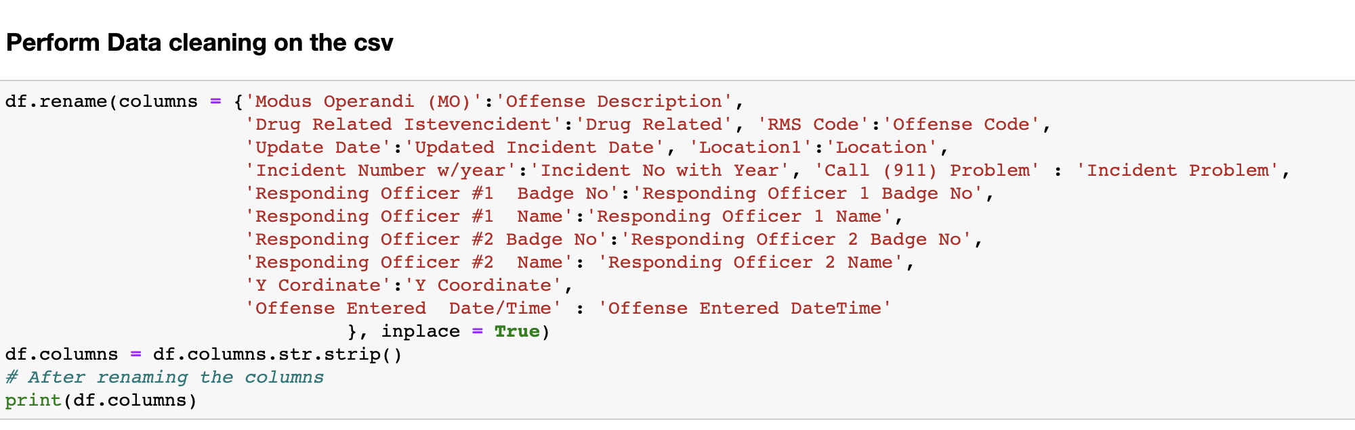

**Test Case 3 : Dropping Duplicates**

Test Description:

Checked if any duplicates present and dropping them if any exists.

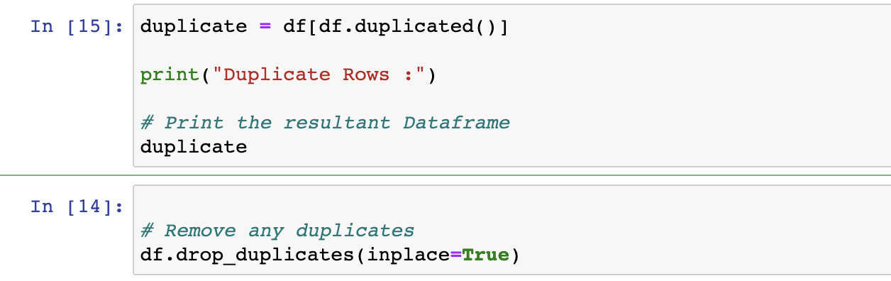

## Challenges Encountered

When working on the project, we encountered some challenges as below:

**Problem:** Limited information on the website for Dallas Police incidents.  
The dataset column names contained acronyms/short forms and detailed information was not present on the website.

**Solution:**Conducted own research to find meaning to the column names.   
Renamed column names according to the business terms.

**Problem:** Processing of large dataset with too many columns

Our dataset Dallas Police Incidents is a large dataset with 86 columns, and we have 1,064,107 records in all. Due to which the data loading with nodes and relationships took a lot of time in Neo4j.

**Solution:**Using Jupyter-lab for data profiling and cleaning  
Splitting the dataset into multiple files for faster loading of data.  
Creating indexes on nodes for faster loading of data.

**Problem:** Bad data present in the dataset for some columns  
Eg: The State column had values like TX, T, Texas for Texas

**Solution**: Performed data cleaning in Python by adding different logic.

**Problem:** Large number of null values present in the dataset.

**Solution:** Handled null values for each column type during data cleaning in python

## End User Instructions

**Steps :**

1. Download the data source from the link below.

Dataset: Dallas Police incidents Open Data  
<https://www.dallasopendata.com/Public-Safety/Police-Incidents/qv6i-rri7>

2. Detailed steps for setting up Python Jupyter Notebook

2.1 Download Python if not already downloaded (follow instructions on <https://www.python.org/downloads/> based on operating system

2.2 Install JupyterLab with pip install command:  
pip install jupyterlab

2.3 Once installed, launch Jupyter-Lab with  
jupyter-lab

2.4 Upload the Dallas_Police_Incidents.ipynb to Jupyter lab.

2.5 Run the complete file to perform data profiling, data wrangling and data cleaning.

3. Detailed steps for setting up Neo4j

3.1 - Download and complete neo4j database installation. Once installed, create a new project and a local database inside the project •

3.2 - Enter name and password for the database and start the database once created.

3.3 - Place the csv file in imports folder of the database

3.4 - Execute the cypher scripts Dallas_cypher_script.txt to create indexes, nodes, and relationships.

3.5 - Click on the nodes, relationships, properties to perform basic analysis on the created data.

4. Detailed steps for visualizing data in Tableau

Step 4.1 - Download Tableau Desktop.

Step 4.2 - Download JDBC connector and do the connection in Tableau following the below link

<https://neo4j.com/developer/kb/how-to-use-the-bi-connector-with-tableau-desktop/>

Step 4.3 - Load the data in Tableau and import the Dallas_Police.twbx to see the visualizations.